MCPB Pulse jet control instrument

User Manual

Overview

The pulse jet control instrument is a cleaning control device used in baghouse dust collectors. It combines a compressed air source and a pulse solenoid valve to achieve automatic cyclic cleaning during the industrial production process, maintaining the resistance of the bag to air within a set range. This improves the dust collection efficiency and processing capacity of the dust collector.

The pulse jet control instrument can sequentially switch multiple pulse solenoid valves, controlling the on/off time of the pulse solenoid valves through its output pulse signal and controlling the compressed air to clean each filter bag in a timed and quantified manner.

Terminology:

- Pulse Width: The duration of a single electrical pulse signal output by the pulse jet control instrument.

- Pulse Interval: The time interval between two electrical pulse signals output by the pulse jet control instrument.

- Jet Cycle: The time taken for the pulse jet control instrument to complete one cycle.

- Jet Cycle Interval: The time from the end of the previous jet cycle to the start of the next jet cycle.

Features of the MCPB Pulse Jet Control Instrument:

1. Compact Design: With an insertion depth of 80mm (compared to 140mm in the previous generation), it saves space.

2. Wide Range of Settings: The pulse interval and pulse width have a wide range of settings to meet all user needs.

3. Additional Jet Cycle Interval Option: Typically set to the default value of "0".

4. Manual Re-blow Mode: Added functionality to control a specific pulse solenoid valve through buttons for point or continuous re-blow.

Technical Specifications:

- Power Supply:220VAC ±10% 50Hz

- Jet Cycle Interval: (0 to 9999) × 10 seconds

- Output Voltage: DC24V or AC220V

- Drive Power: 25W

- Pulse Interval: 1 to 9999 seconds

- Dimensions:160mm (width) × 80mm (height) × 80mm (depth)

- Installation Method: Panel snap-in installation, no支架 required

- Weight: 0.545kg

- Cutout Size:152 ±0.7mm × 76 ±0.7mm

Wiring Method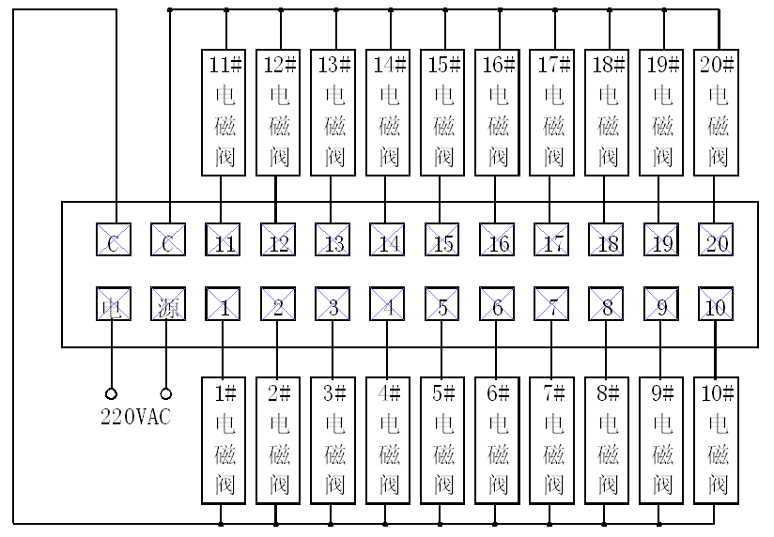

The wiring terminal connection diagram for the 10-way and 20-way pulse jet control instruments with the pulse solenoid valves is as follows:

- Power Terminal: Connect to 220VAC

- C Terminal: Connect to the common terminal of the pulse solenoid valve

- 1 to 20 Terminals: Connect to the pulse solenoid valves in sequence

Parameter Adjustment

1. Pulse Width Adjustment:

- Press and hold the \*\*Set/Return\*\* key to display \*\*S1 (Pulse Width)\*\*.

- Press the \*\*Set/Return\*\* key again to display the value for the pulse width (0.01 to 99.99 seconds).

- Use the \*\*+\*\* and \*\*-\*\* keys to adjust to the required pulse width.

2. Pulse Interval Adjustment:

- Press the \*\*Set/Return\*\* key again to display \*\*S2 (Pulse Interval)\*\*.

- Press the \*\*Set/Return\*\* key again to display the value for the pulse interval (1 to 9999 seconds).

- Use the \*\*+\*\* and \*\*-\*\* keys to adjust to the required pulse interval.

3. Number of Pulse Paths:

- Press the \*\*Set/Return\*\* key again to display \*\*S3 (Number of Pulse Paths)\*\*.

- Press the \*\*Set/Return\*\* key again to display the value for the number of pulse paths (1 to 20 paths).

- Use the \*\*+\*\* and \*\*-\*\* keys to adjust to the required number of pulse paths.

4. Jet Cycle Interval Adjustment:

- Press the \*\*Set/Return\*\* key again to display \*\*S4 (Jet Cycle Interval)\*\*.

- Press the \*\*Set/Return\*\* key again to display the value for the jet cycle interval (0 to 9999) × 10 seconds.

- Use the \*\*+\*\* and \*\*-\*\* keys to adjust to the required jet cycle time. If no jet cycle interval is needed, set this parameter to 0.

5. Manual Re-blow Mode:

- Press the \*\*Set/Return\*\* key again to display \*\*S5 (Manual Re-blow Mode)\*\*.

- Press the \*\*Set/Return\*\* key again to display the value 0 or 1.

- Use the \*\*+\*\* and \*\*-\*\* keys to select 0 or 1. The default setting is 0, which is the point re-blow mode. Setting it to 1 enables the custom re-blow mode.

6. End of Setting:

- Press the \*\*Set/Return\*\* key again to end the setting. The pulse jet control instrument enters the self-test state, displays a loop, and then enters the working state according to the set parameters.

How to Use the Manual Re-blow Mode:

- In the normal working state of the pulse jet control instrument, press the \*\*Manual/Shift\*\* key to enter the manual re-blow mode.

- Use the \*\*+\*\* and \*\*-\*\* keys to select the pulse solenoid valve, then press the \*\*Re-blow\*\* key to start manual re-blow.

- When \*\*S5\*\* is set to 0, pressing the \*\*Re-blow\*\* key once will cause the selected pulse solenoid valve to blow once, with the blowing duration set by \*\*S1\*\*.

- When \*\*S5\*\* is set to 1, pressing the \*\*Re-blow\*\* key will cause the selected pulse solenoid valve to blow continuously until the \*\*Re-blow\*\* key is released. In this case, the \*\*Re-blow\*\* key acts as a control switch for the selected pulse solenoid valve, allowing for re-blowing for any duration and any number of times.

Selection Guide

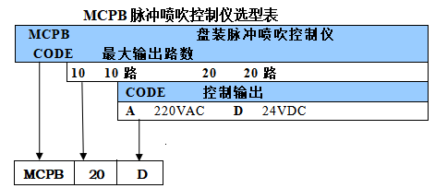

MCPB Pulse Jet Control Instrument Selection Table

- MCPB:\*\* Panel-mounted pulse jet control instrument

- CODE:\*\* Maximum output paths

- \*\*10:\*\* 10 paths

- \*\*20:\*\* 20 paths

- \*\*CODE:\*\* Control output

- \*\*A:\*\* 220VAC

- \*\*D:\*\* 24VDC

\*\*Example Selection:\*\*

- \*\*Selection Result:\*\* MCPB-20D

- \*\*Explanation:\*\* MCPB pulse jet control instrument, capable of controlling up to 20 paths of 24VDC pulse solenoid valves.

Maintenance and Care

1.After using the pulse jet control instrument, daily inspection of its operation is required, and any faults found should be addressed promptly.

2. No Display on the Digital Tube After Powering On:

- Check if the power cord on the wiring terminal is loose, if the switch is turned on (I is the on position).

3. Display is Normal but a Pulse Valve is Always Open:

- Check if the corresponding electronic switch is damaged.

4. Display is Normal but Two Electromagnetic Pulse Valves Work Simultaneously:

- Check if there is any collision or electrical short in the control instrument.

5. Display is Normal but Electromagnetic Valves Do Not Work:

- Check if the common terminal of the output wire terminal is in reliable contact.

6. Digital Tube on the Pulse Jet Instrument is Flashing:

- Check if the power supply is normal.

\*\*Yantai Allmy Control Engineering Co., Ltd.\*\*

\*\*Address\*\*: No. 61 Hongfu Street, Fushan District, Yantai, Shandong, China

\*\*Tel\*\*: +86-535-6988179 / +86-535-6988166/7

\*\*Website\*\*: www.allmy.com.cn