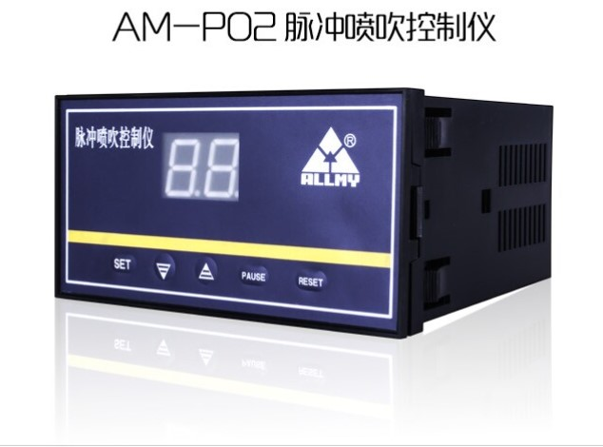

Overview

The AM-P02 Series Pulse-Jet Controller is the primary control device for the pulse-jet cleaning system of baghouse dust collectors. Its output signals directly control solenoid valves to sequentially release compressed air for cleaning filter bags, ensuring the dust collector’s resistance remains within the set range and maintains optimal dust removal efficiency.

The AM-P02 Series includes three models, capable of outputting a maximum of **8, 16, or 32 control signals**, respectively. Both **pulse width** and **pulse interval** can be adjusted via the front panel. Each model allows users to configure the actual number of output channels through the panel.

Technical Specifications
- Power Supply:
- 220V AC ±15%, 50Hz
- 24V DC ±15%
- Power Consumption: <5W
- Output:
- 24V DC/1A
- 220V AC/3A
- Pulse Interval: Adjustable from 1–99 seconds
- Pulse Width: Adjustable from 10–910 ms (10 ms increments)
- Operating Environment:
- Temperature: -25°C to 60°C
- Humidity: ≤95% RH
- Dimensions: 160mm (W) × 80mm (H) × 140mm (D)
- Installation: Snap-in mounting (no bracket required)
- Cutout Dimensions: 152±0.7mm × 76±0.7mm
- Weight: 600g

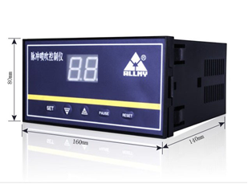

Parameter Adjustment
1. Enter Setup Mode: Press and hold the **SET** key for 3–5 seconds until the display shows “00”.
2. Set Output Channels:
- Press **SET** to display “1”.
- Press **SET** again to show the current channel count (e.g., “06” = 6 channels).
- Use **▲** to increase or **▼** to decrease the number.
3. Adjust Pulse Interval:
- Press **SET** to display “2”.
- Press **SET** again to show the interval value (e.g., “07” = 7 seconds).
- Use **▲**/▼** to adjust in 1-second increments.
4. Adjust Pulse Width:
- Press **SET** to display “3”.
- Press **SET** again to show the width value (e.g., “20” = 200 ms).
- Use **▲**/▼** to adjust in 10 ms increments.
5. Save Settings:
- Press **SET** until “01” is displayed. The controller restarts from Channel 1.
6. Additional Functions:
- RESET: Returns to Channel 1 during operation.
- PAUSE: Temporarily halts operation. Press again to resume.
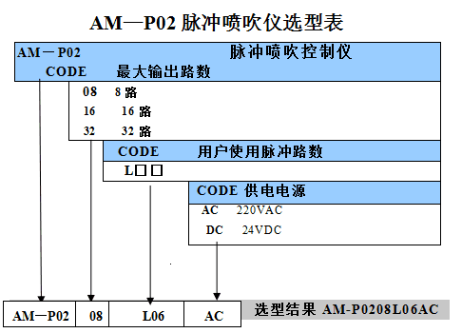

Notes
- The controller supports **24V DC** or **220V AC** outputs. Ensure solenoid valves match the voltage. Custom voltages are available upon request.
- Pulse Solenoid Valves: These valves act as switches for compressed air, controlled by the controller to maintain optimal dust removal.

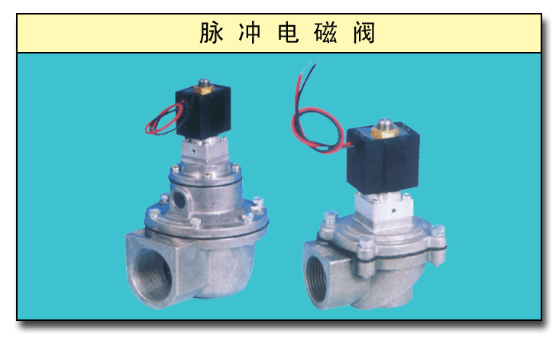

Custom Options (Specify When Ordering)
1. Extended Pulse Interval: 1–99 minutes (1-minute increments).
2. Extended Pulse Width: 0.05–5 seconds (0.05-second increments).
3. Special Power Supplies:
- 220V AC, 60Hz
- 110V AC, 50Hz

Wiring Diagrams
- **24V DC Output Wiring Diagram**:
[Insert wiring diagram with labeled terminals: Power (24V DC), Output Channels, Common Terminal]

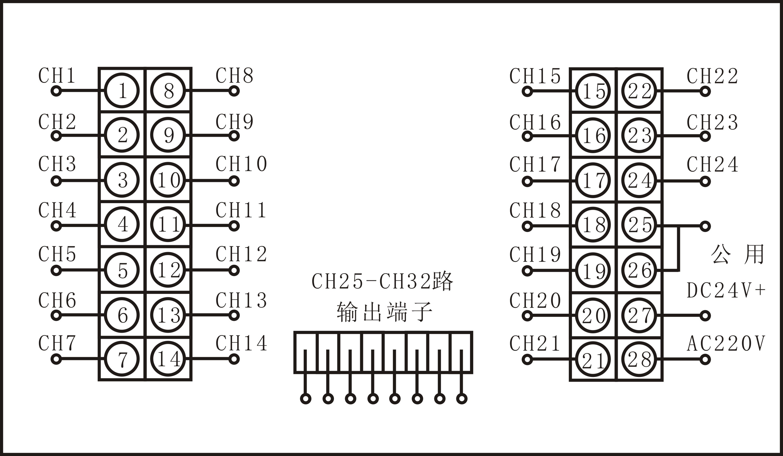

- 220V AC Output Wiring Diagram:
[Insert wiring diagram with labeled terminals: Power (220V AC), Output Channels, Common Terminal]

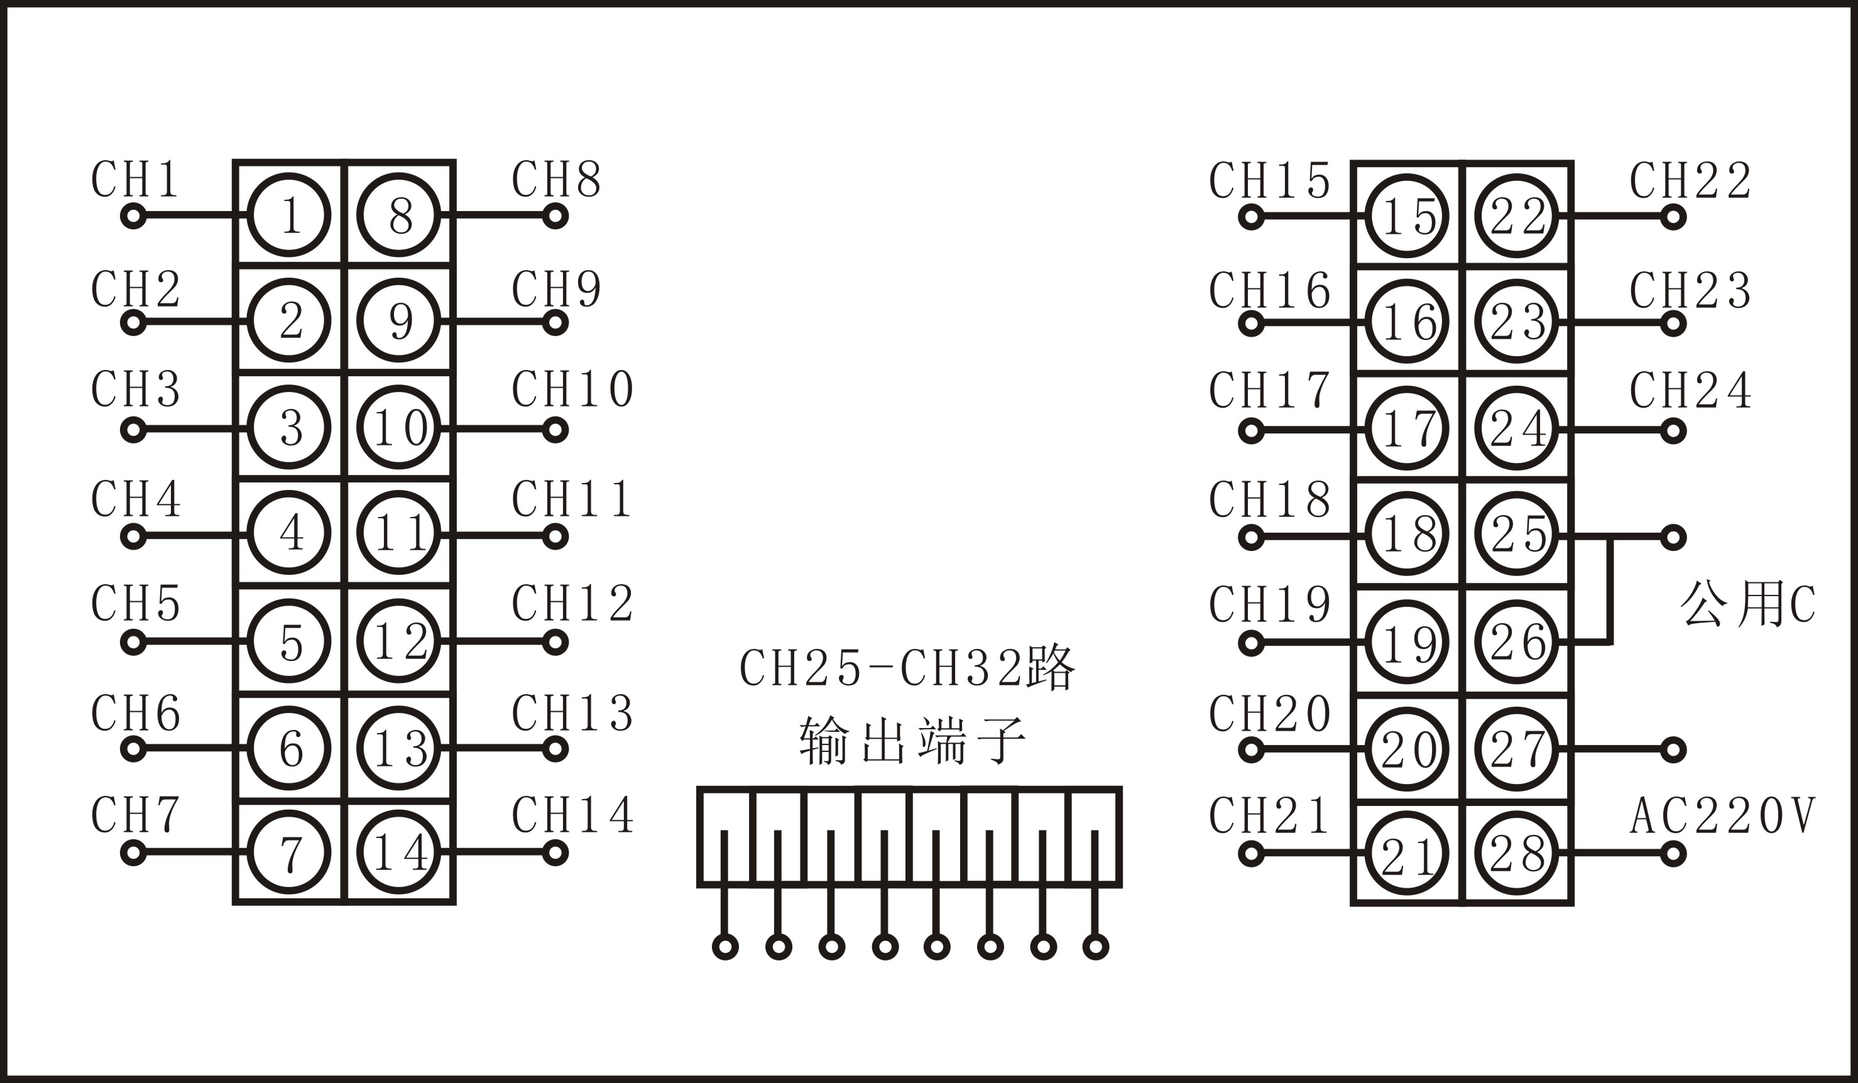


Yantai Allmy Control Engineering Co., Ltd.
Address: No. 61 Hongfu Street, Fushan District, Yantai, Shandong, China
Tel: +86-535-6988179 / +86-535-6988166/7
Website: www.allmy.com.cn

