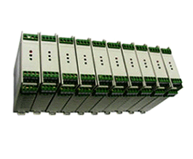

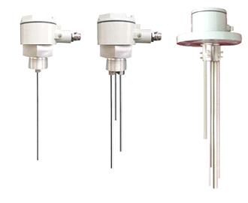

AM-DJ Electrode Level Controller

The AM-DJ Electrode Level Controller is an instrument designed for liquid level detection and control. It consists of two main components: a level detection electrode and a controller.

Types

The AM-DJ Electrode Level Controller is available in **integrated** and **split** configurations:

- Integrated Type: The controller’s circuit board is housed within the junction box of the level detection electrode, forming a compact, single-unit structure.

- Split Type: The controller and level detection electrode are installed separately. The controller can be mounted either on a DIN rail inside a control cabinet or on a panel.

To suit different environments, the level detection electrode is offered in **plastic housing** or aluminum alloy explosion-proof housing**. Connection fittings include **nylon/PP polypropylene plastic** or **stainless steel**, selectable based on application requirements.

Electrode Configurations

The number of electrodes varies (1 to 5) to meet diverse functional needs:

- 1 Electrode: Suitable for liquid level alarms in **metal tanks** or pipeline leak detection (the tank itself serves as the common electrode).

- 2 Electrodes: Ideal for **non-metallic tanks**, single-point level alarms, or non-metallic pipeline leak detection.

- 3 Electrodes (Most Common): Used for **inlet (filling)** or **outlet (draining)** control.

- 4 Electrodes**: Adds **upper/lower limit alarms** to inlet/outlet control, preventing overflow or pump dry-run conditions.

- 5 Electrodes: Enables simultaneous **inlet/outlet control** with **dual alarms** for ultra-high and ultra-low levels.

Key Features

- Compact controller design for dense DIN rail mounting in cabinets.

- Industrial-grade electrodes with robust construction and customizable lengths.

- Localized level control and alarm functionality.

- Anti-interference design with isolated switching power supply for safety and reliability.

Technical Parameters

- Power Supply: 220V AC or 24V DC (isolated switching power supply).

- Relay Output Capacity: 220V AC/2A, 24V DC/2A.

- Ambient Temperature: -20°C to 70°C.

- Ambient Humidity: ≤85% RH.

- Electrode Material: Standard 304 stainless steel (other materials optional).

- Liquid Contact Temperature:

- Plastic: -20°C to 70°C

- 304 Stainless Steel: -20°C to 180°C

- Connection Types: Threaded (G1 ½", G1 M27×2, G1") or flanged

Compatible Media: Liquids with conductivity ≥20 μS/cm (e.g., distilled water).

Split Controller Dimensions

- DIN Rail Mounting: 90mm (H) × 25mm (W) × 113mm (D).

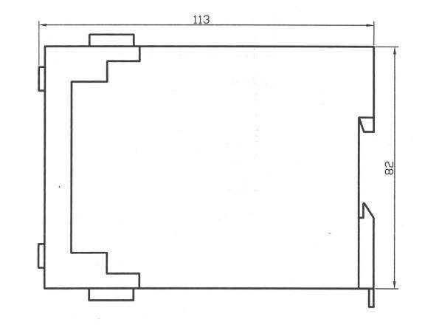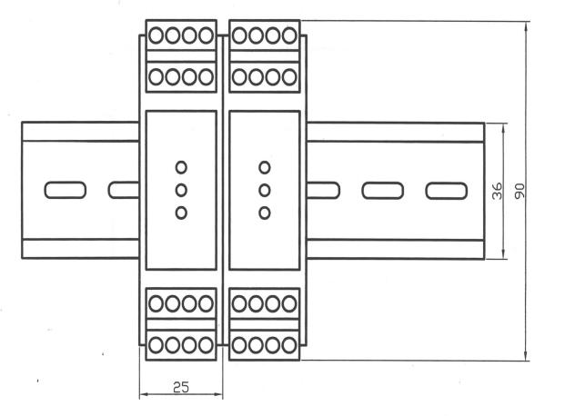 Panel Mounting: Cutout size 45mm (W) × 92mm (H) × 110mm (D).

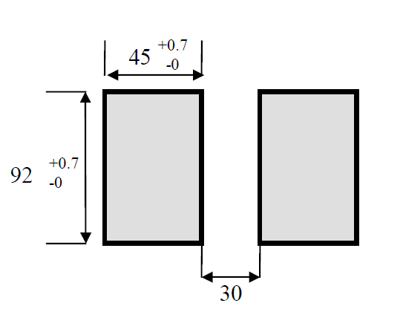 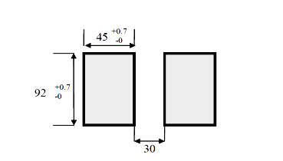

Application Example: 3-Electrode Level Controller

The 3-electrode configuration is widely used for **automatic pump/motorized valve control**:

- Inlet Control:

- When the level drops **below the lower limit**, the relay energizes (yellow indicator ON), opening the inlet valve or starting the pump.

- When the level rises **above the upper limit**, the relay de-energizes (yellow indicator OFF), closing the inlet valve or stopping the pump.

- Outlet Control:

- When the level exceeds **the upper limit**, the relay energizes (yellow indicator ON), opening the outlet valve or starting the pump.

- When the level falls **below the lower limit**, the relay de-energizes (yellow indicator OFF), closing the outlet valve or stopping the pump.

Note:

- Function Switching: Inlet/outlet control modes can be selected via an internal jumper:

- Inlet Control: Jumper on the yellow LED side.

- Outlet Control: Jumper on the red LED side.

- Alternatively, users may swap the relay’s NO (Normally Open) and NC (Normally Closed) wiring to switch between control modes.

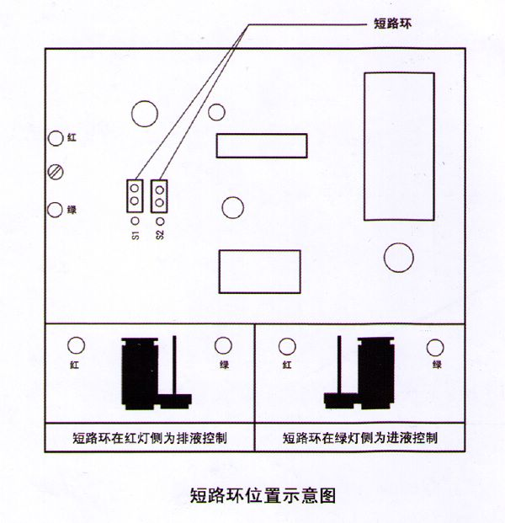

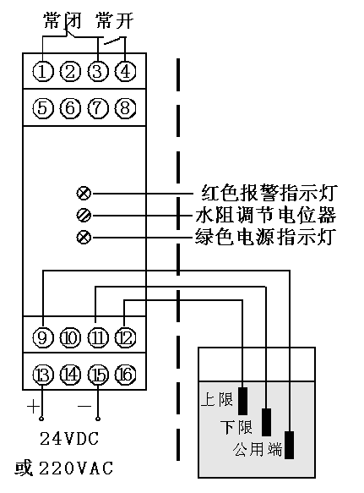

A typical level control configuration: the pump is activated when the liquid level drops below the lower setpoint and deactivated when it rises above the upper setpoint.

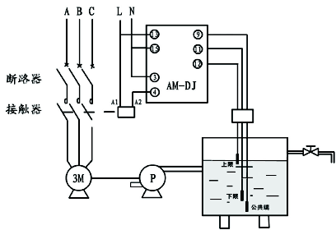

A typical dewatering control configuration: the pump is activated when the liquid level rises above the upper setpoint and deactivated when it falls below the lower setpoint.

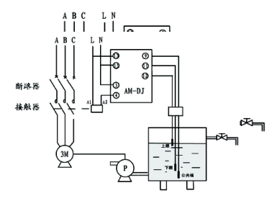

A four-electrode level controller is configured with high/low-level alarm functionalities in addition to standard liquid feed/discharge operations. This design safeguards against tank overflow triggered by exceeding the high-level threshold and protects pumps from dry-running conditions caused by falling below the low-level threshold.

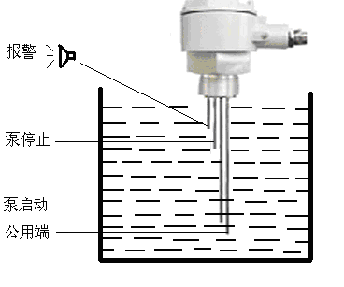

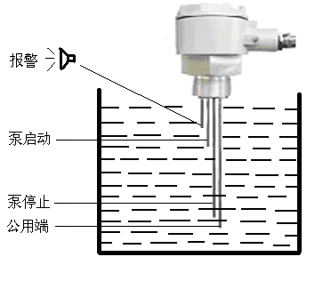

Controller function description: Based on liquid filling or draining control, an extra relay is added to provide limit alarm. (When the internal shorting ring is on the red light side, it activates drainage control with high-level alarm; when on the green light side, it enables filling control with low-level alarm).

The external wiring diagram is shown below.

Five-electrode level controller:

This controller adds both high-level and low-level alarms to liquid filling/draining functions, preventing overflow from excessive water levels and pump dry-running due to extremely low levels.

- Filling control:

Relay engages (green alarm light ON) when level drops below lower limit;

Relay disengages (green light OFF) when level rises above upper limit.

- Draining control:

Relay engages (green alarm light ON) when level exceeds upper limit;

Relay disengages (green light OFF) when level falls below lower limit.

- Over-limit alarms:

Red alarm light ON (over-upper-limit relay engaged) if level exceeds the ultra-high threshold;

Yellow alarm light OFF (over-lower-limit relay engaged) if level drops below the ultra-low threshold.

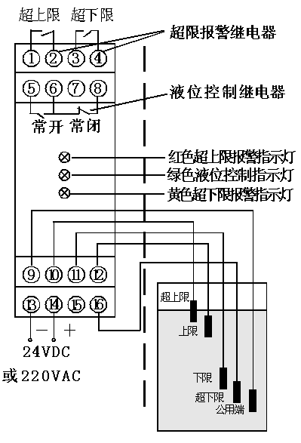

Other wiring diagrams are shown below

