AM88 Series Capacitive Switch

User Manual

Yantai Aomailuo Control Engineering Co., Ltd.

Safety Instructions

● Read this manual thoroughly before use and retain it for future reference.
● Strictly follow the operating procedures and precautions outlined in this manual.
● Upon receipt, carefully inspect the instrument and accessories for transport damage. If damage is detected, immediately notify our company or distributor and retain the packaging for return processing.
● Do not attempt to repair the instrument yourself in case of malfunction. Contact our company or authorized service centers directly. Unauthorized repairs may void warranties and cause safety hazards.

1. Overview
The AM88 Series Capacitive Level Switch is an intelligent level measurement device utilizing advanced **radio frequency (RF) capacitive technology**. It converts material level changes in containers into capacitance variations: the probe acts as one electrode, while the container wall (or auxiliary probe) serves as the other. The electronic module translates capacitance changes into pulse frequency variations, processed by a microcontroller to set and trigger alarm points.

Advantages over Traditional Methods:
- Eliminates low accuracy and complex calibration (e.g., charge/discharge methods).
- Single-button setup for alarm point configuration with permanent storage (retains settings for up to 10 years).
- Adjustable alarm points via simple reconfiguration.

Applications:
Widely used in liquid, powder, and solid level measurement/control for industries including petroleum, chemical, power, metallurgy, food, pharmaceuticals, and feed processing. Available in **single-point, dual-point, three-point, and four-point configurations**.

2. Key Features
- Non-volatile Memory: Retains settings for 10 years without power.
Advanced RF Capacitive Detection**: Compatible with solids, powders, liquids (conductive/non-conductive), and highly corrosive media.
- Temperature range: -30°C to 180°C
- Pressure resistance: Up to 4 MPa
- Anti-Coating Interference: Immune to material buildup or splashing on the probe.
- One-Touch Alarm Setting: Vibration-resistant button prevents accidental adjustments.
- Flexible Alarm Modes: Configurable for high-level (upper) or low-level (lower) alarms.
- PTFE-Coated Probe: Suitable for high-temperature/high-pressure environments.
- Explosion-Proof Certification: Exd II CT4 rating.

3. Installation
Mounting Methods
- Top-Mounted Installation(vertical from container top):
- Avoid direct material impact zones.
- Maintain >200 mm clearance from container walls.
- Side-Mounted Installation(on container wall):
- Tilt probe downward 20–30° to minimize material adhesion.

Installation Notes
- Use a wrench on the process connection, **not the housing**, during installation/removal.
- Ensure proper grounding (<1 Ω) for non-metallic containers (auxiliary probe required).

- Probe Types

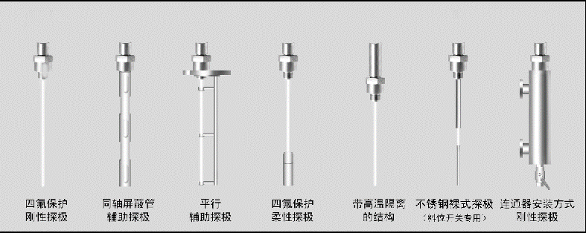
Description
Standard Probe For general solids/powders. No auxiliary probe needed in metallic containers.
Anti-Corro：PTFE-coated for harsh chemical environments. | Flexible Probe：Recommended for lengths >3 meters.
Shielded Probe ：Compensates for conductive material adhesion; immune to condensation.

Notes:
1. Auxiliary probes required for non-metallic containers.
2. Probe embedment depth: ≥100 mm.

AM8831 Single-Point Capacitive Switch

The AM8831 single-point capacitance switch features an **anti-clogging structure**, making it suitable for material level alarms across various applications. It offers **easy installation** and **flexible configuration**. The switch is available in a **bare probe design** for detecting solid particles and powders, as well as a **specialized structure with corrosion-resistant materials** for monitoring corrosive media. Additionally, it includes an **LCD display for real-time capacitance value monitoring** and **explosion-proof versions** compliant with international safety standards (e.g., ATEX/IECEx), ensuring adaptability to diverse industrial environments.

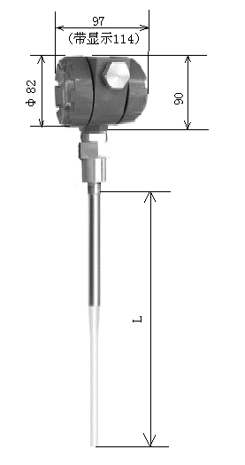

Technical Specifications

-Ambient Temperature: -30°C to 70°C
- Humidity: ≤95% RH
- Protection Rating: IP65
- Power Supply: 220 V AC ±10% or 24 V DC ±15%
- Relay Contact Rating: 250 V AC /3 A or 24 V DC /5 A
- Dielectric Constant: ε ≥1.6
- Delay Time Settings: 0, 2, 4, 8, 16, 32 sec (default: 2 sec)
- Power Consumption: ≤1 W
- Explosion Proof: Exd II CT4
- Electrical Interface: M20×1.5
- Probe Length: 350 mm (customizable)
- Process Temperature:
- Standard: -20°C to 80°C
- High-Temp: -25°C to 180°C
- Process Pressure: -0.1 to 4.0 MPa

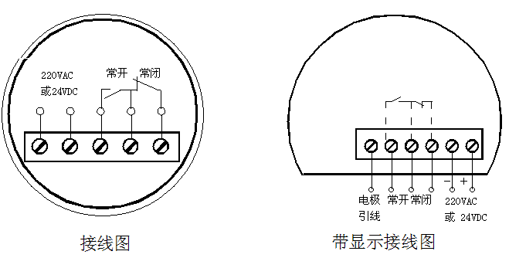

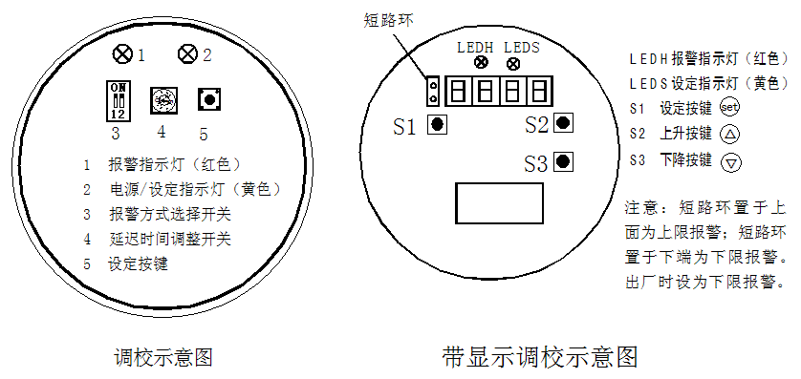

Wiring Diagram
(Refer to attached schematic for terminal connections)

Calibration Procedure
Standard AM8831 (Non-Display)
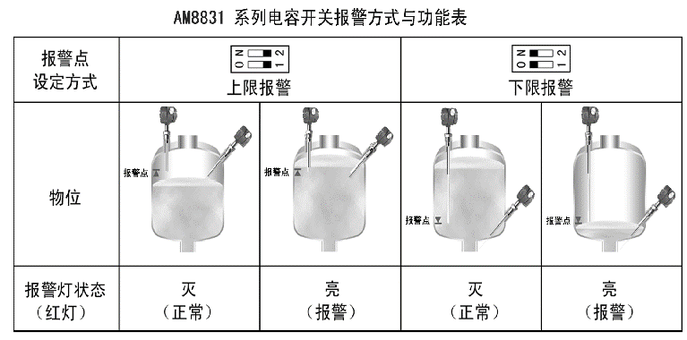

1. Power On:
- Open the terminal cover and connect power/load per the wiring diagram.
- Yellow power indicator lights up.
2. Set Delay Time:
- Adjust the DIP switch (positions 0–9):
- 0: 0 sec | 1: 2 sec | 2: 4 sec | 3: 8 sec
- 4: 16 sec | 5: 32 sec | 6–9: Reserved
3. Alarm Point Configuration:
- Select High/Low Alarm Mode via the mode switch.
- Press and hold the setting button for 3–5 sec until the yellow setting LED flashes.
- Adjust material level to the desired alarm point, press the button again, and release. LED stops flashing—configuration complete.

Calibration Steps for Single-Point Capacitance Switch with Display

1. Open the terminal cover and select the alarm mode (upper or lower limit) based on design requirements:
- Upper limit: Position the short-circuit ring at the **top**.
- Lower limit: Position the short-circuit ring at the **bottom**.

2. Connect the wiring according to the diagram. After confirming the wiring is correct, **power on the device. The digital display will show the current capacitance value.

3. Set the Alarm Point
a. Press and hold the button for 3–5 seconds** until the setting indicator (yellow) flashes, then release the button.
b. Press the button again to enter the alarm setup program (display shows **P-01**). Press the button once more to view the **original alarm point capacitance value**. Use the **▲/▼ buttons** to adjust the alarm point, then press the button to confirm.
c. The display will switch to **P-02** for **hysteresis setting**. Press the button to view the original hysteresis value, adjust it using the **▲/▼ buttons**, and press the button again to confirm.
d. The yellow indicator stops flashing, and the device returns to **measurement mode**, displaying the real-time capacitance value.
Alarm Modes & Function Table

AM8832 Dual-Point Capacitive Switch

The AM8832 Dual-Point Capacitive Switch is suitable for feeding and discharging control of various materials, featuring easy installation and flexible configuration. It offers a bare probe structure for detecting solid particles and powders, a corrosion-resistant design for harsh media, an LCD display for real-time capacitance monitoring, and explosion-proof models for hazardous environments.

Technical Specifications
- Ambient Temperature: -30°C to 70°C
- Ambient Humidity: ≤95% RH
- Protection Rating: IP65
- Power Supply: 220V AC ±10% or 24V DC ±15%
- Relay Contact Rating: 250V AC/3A or 24V DC/5A
- Relative Dielectric Constant: ε ≥1.6
- Delay Time: 0, 2, 4, 8, 16, 32 seconds
- Power Consumption: ≤1W
- Explosion-Proof Rating: ExdⅡCT4
- Electrical Interface: M20×1.5
- Probe Length: 350mm (customizable)
-Process Temperature:
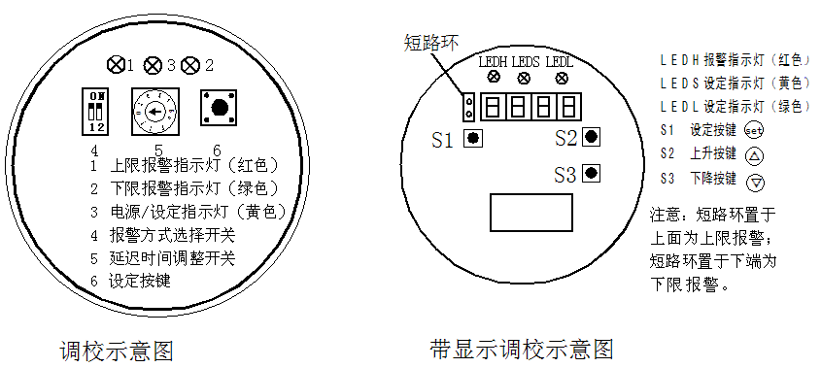

- Standard: -20°C to 80°C
- High-Temperature: -25°C to 180°C
- Process Pressure: -0.1 to 4.0 MPa
Wiring Diagram
(Insert wiring diagram here)
Calibration Schematic
(Insert calibration schematic here)

Calibration Procedure
For Standard Dual-Point Capacitive Switch:
1. Power Connection:
- Open the terminal cover and connect the power supply and load according to the wiring diagram. The power indicator (yellow) should remain lit.
2. Set Delay Time:
- Adjust the delay time switch to the desired position (factory default: Position 1).
- Position 0: 0 sec | Position 1: 2 sec | Position 2: 4 sec | Position 3: 8 sec
- Position 4: 16 sec | Position 5: 32 sec | Positions 6–9: Unused
3. Alarm Point Setting:
- Lower Limit Alarm:
a. Toggle the alarm mode switch to ON.
b. Press and hold the **SET** button for 3–5 seconds until the setting indicator (yellow) flashes.
c. Fill the material to the lower limit position, press **SET** once, then release. The indicator stops flashing, confirming completion.
- Upper Limit Alarm:
a. Toggle the alarm mode switch to **12**.
b. Press and hold the **SET** button for 3–5 seconds until the setting indicator flashes.
c. Fill the material to the upper limit position, press **SET** once, then release. The indicator stops flashing, confirming completion.

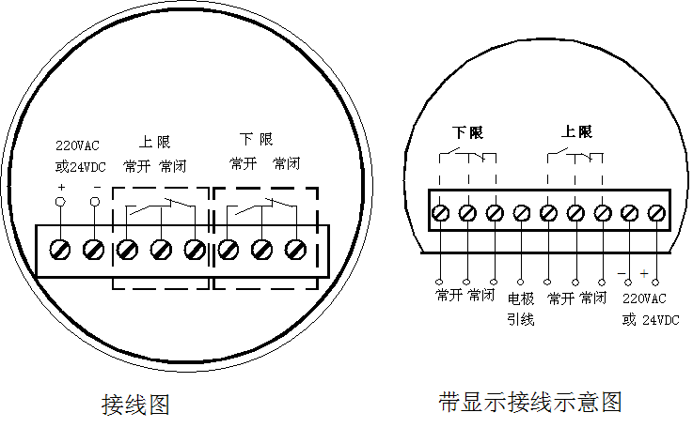

For Dual-Point Switch with LCD Display:
1. Initial Setup:
- Open the terminal cover, connect wiring, and power on. The power indicator (yellow) lights up, and the LCD displays capacitance values. Record values at different material levels for reference.
2. Alarm Point Setting:
- Lower Limit Alarm:
a. Press and hold **SET** for 3–5 seconds until the indicator flashes. Release the button.
b. Press **SET** again to enter **P-01** (lower limit setting).
c. Press **SET** once more to display the current value. Adjust using **▲/▼** buttons, then press **SET** to confirm. The display switches to **P-02** (upper limit setting).
- Upper Limit Alarm:
a. Press **SET** to show the current upper limit value. Adjust using **▲/▼** buttons, then press **SET** to confirm. The display switches to **P-03** (delay time setting).
- Delay Time Adjustment:
a. Press **SET** to display the current delay time. Adjust using **▲/▼** buttons, then press **SET** to confirm.
b. Press **SET** again to exit. The indicator stops flashing, and the LCD returns to real-time capacitance display.
Alarm Modes & Function Table

AM8834 Four-Point Capacitive Switch

The AM8834 Capacitive Switch features multi-point alarm functionality with a single sensor, supporting three or four alarm points. It is designed for multi-level material monitoring in various applications, offering simple installation, flexible configuration, and multiple mounting options.

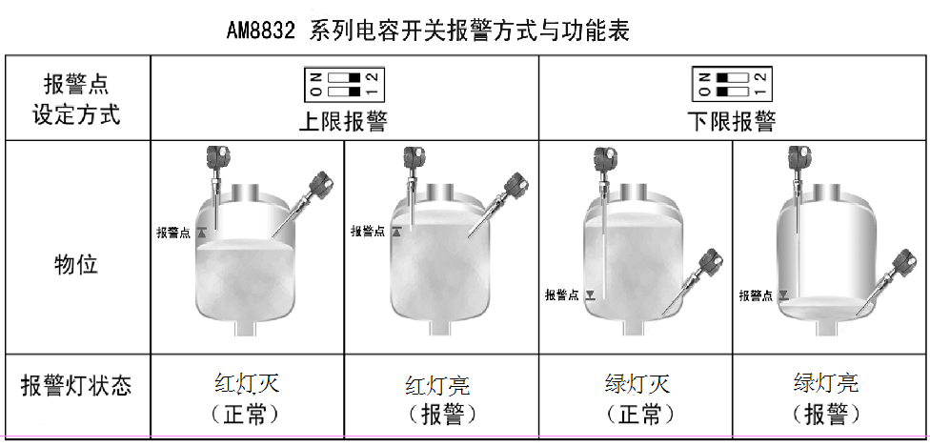

Technical Specifications

- Ambient Temperature: -30°C to 70°C
- Ambient Humidity: ≤95% RH
- Protection Rating: IP65
- Power Supply: 24V DC ±15%
- Relay Output: 220V AC/1A or 24V DC/1A
- Relative Dielectric Constant: ε ≥1.6
- Power Consumption: ≤3W
- Explosion-Proof Rating: ExdⅡCT4
- Electrical Interface: M20×1.5
- Probe Length: 350mm (customizable)
- Process Temperature:
- Standard: -20°C to 80°C
- High-Temperature: -25°C to 180°C
- Process Pressure: -0.1 to 4.0 MPa
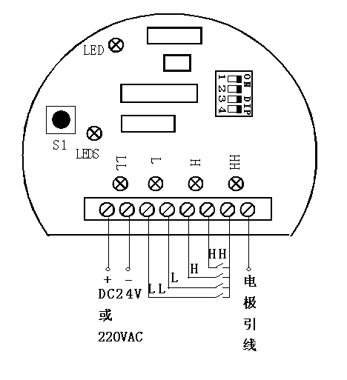
Wiring Diagram

Calibration Procedure
1. Power Connection:
- Open the terminal cover and connect the power supply and load according to the wiring diagram. The power indicator (green) should remain steadily lit.

2. Alarm Point Setting:
- Note: After configuring each alarm point, **reset the DIP switch to its original position**.
- a. Lower-Lower Limit (LLL) Alarm
:
- Set **DIP Switch 1** to the **ON** position.
- Press and hold the **SET** button for **3–5 seconds** until the setting indicator (yellow) **flashes.
- Fill the material to the **LLL alarm position**, then press the **SET** button once. The yellow light stops flashing, confirming LLL alarm setup.
- Reset **DIP Switch 1** to its original position.
b. Lower Limit (LL) Alarm
:
- Set **DIP Switch 2** to the **ON** position.
- Repeat the steps above for the **LL alarm position**.
- Reset **DIP Switch 2** to its original position.
- c. Upper Limit (UL) Alarm:
- Set **DIP Switch 3** to the **ON** position.
- Repeat the steps for the **UL alarm position**.
- Reset **DIP Switch 3** to its original position.
- d. Upper-Upper Limit (UUL) Alarm**:
- Set **DIP Switch 4** to the **ON** position.
- Repeat the steps for the **UUL alarm position**.
- Reset **DIP Switch 4** to its original position.

3. Factory Presets for Custom Orders:
- For special orders, alarm points can be **pre-configured at the factory** based on user requirements, enabling **plug-and-play installation** without on-site calibration.

Alarm Modes & Function Table

AM8834 Alarm Modes & Function Table

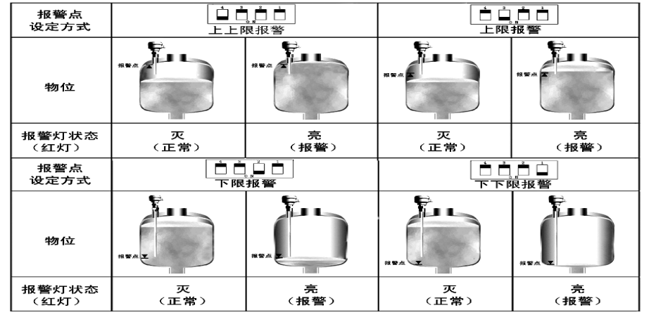

Model Selection

