AM693-III Pressure Transmitter

Composed of a pressure sensor, signal conversion circuit, housing, and process connection fittings. The pressure sensor utilizes a filling fluid to transmit pressure between the piezosensitive element and the SS316 stainless steel diaphragm. The minute displacement of the sensitive element alters the sensor’s output, which is then converted by the signal conversion circuit into standard 4–20 mA DC or 1–5 V DC signals. To accommodate legacy signal standards used by small and medium enterprises, this product also offers 0–10 mA current output.
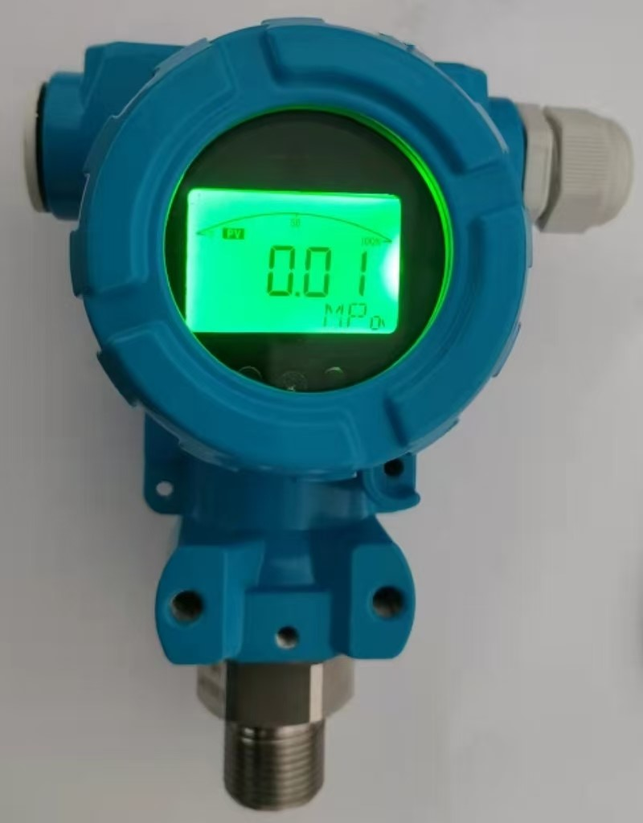

Technical Specifications:

◆ Operating temperature range: -20 to 50°C
◆ Ambient relative humidity: <95% RH
◆ Supply voltage: 12–36 V DC
◆ Output signal: 4–20 mA DC (other output signals available upon request)
◆ Measurement range: -0.1 MPa to 70 MPa (refer to the selection table for details)
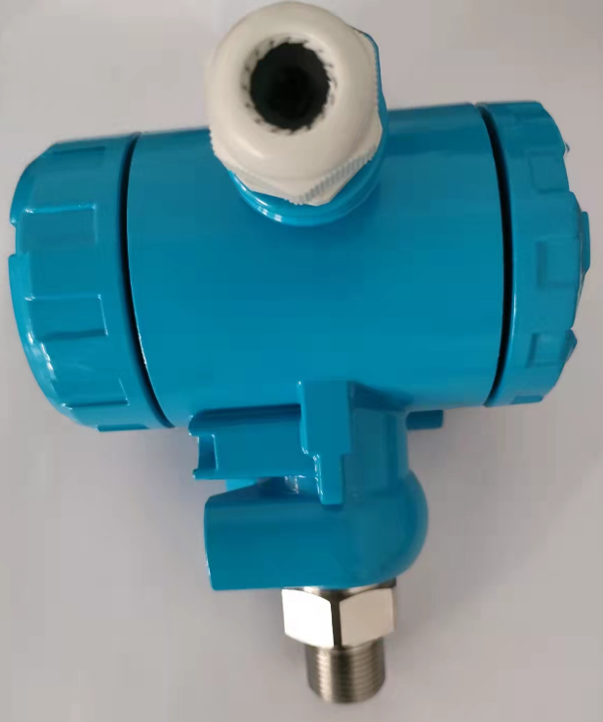
◆ Zero adjustment: Continuously adjustable within 30% of the measurement range
◆ Overpressure limit:
- ≤34 kPa range: 138 kPa
- Other ranges: 3–10 times the rated range
◆ Color: Lake blue
◆ Dimensions: 150 × 100 × 115 mm
◆ Weight: Approx. 0.8 kg (excluding flange structure)
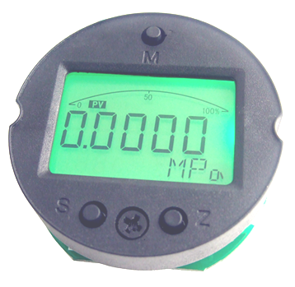
◆ Protection rating: IP65 (splash-proof)

Calibration
The pressure transmitter is pre-calibrated according to order requirements before delivery, and no additional adjustment by the user is necessary. If you need to adjust the range and zero point, first unscrew the side cover of the transmitter and use the zero and span keys. For specific adjustment procedures, please consult the manufacturer.

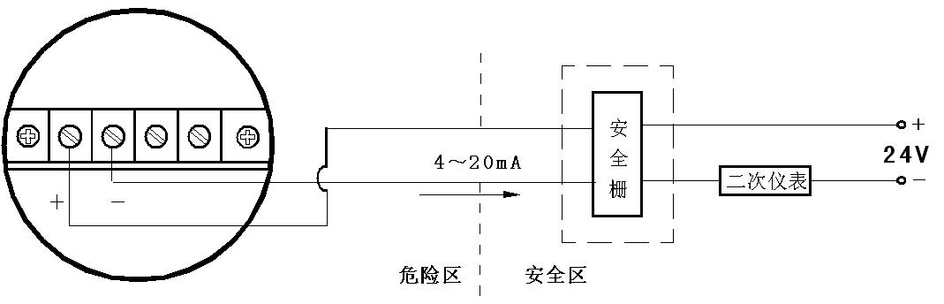

AM693-III Series Gauge Pressure (GP)/Absolute Pressure (AP) Transmitters Model Selection Table

