AM9080S Smart Capacitive Level Gauge

User Manual

Yantai Aomailuo Control Engineering Co., Ltd.

Important Notice

● Read this manual thoroughly before use and retain it for future reference.
● Strictly adhere to the operating procedures and precautions outlined in this manual.
● Upon receipt, carefully unpack and inspect the level gauge and accessories for any shipping damage. If damage is detected, notify our company or distributor immediately and retain the packaging for resolution.
● Do not attempt to repair a malfunctioning device. Contact our company or an authorized service department directly to avoid operational disruptions.

AM9080S Smart Capacitive Level Gauge

一、 Overview
Founded in 1993, our company specializes in research, development, and production of level measurement and control technologies. The AM9080S capacitive level gauge incorporates advanced foreign technology and manufacturing processes, simplifying complex liquid level measurement tasks.

- Key Features
Capable of measuring high-temperature, high-pressure, corrosive, and viscous liquids.
◆ Detects water layer height in oil-water interfaces.
◆ Supports on-site and remote calibration using a HART handheld communicator.

三、 Applications
Primarily used for liquid level measurement in:
◆ Petrochemical Industry**: Heavy oil, light oil, lubricants.
◆ Corrosive Liquids**: Acids, alkalis, brine, industrial/domestic wastewater, electroplating/electrolytic solutions.
◆ Food & Beverage: Juice, liquor, beer, milk, soy sauce, vinegar.
◆ Viscous Liquids: Emulsions, adhesives, molten media.

四、 Technical Specifications
◆ Cable Interface: M20×1.5, stainless steel SS304 seal.
◆ Power Supply: 24VDC ±10%.
◆ Output: 4–20mA DC (two-wire system).
◆ Accuracy: 0.5% (4–20mA range).
◆ Ambient Temperature: -25 to +70℃.
◆ Ambient Humidity: 0–95% RH.
◆ Medium Temperature: -25 to +220℃.
◆ Measurement Range: 0–5000pF.
◆ Process Pressure: -0.1 to 4.0MPa.
◆ Housing: Explosion-proof aluminum alloy, suitable for humid and acidic environments.
◆ Probe: Compatible with rigid or flexible probes.

五、Probe Types
- Rigid Probe: ≤3m in length.
- Flexible Probe: Requires tensioning and fixation at the tank bottom.
- Probe with Auxiliary Electrode: For non-metallic containers.
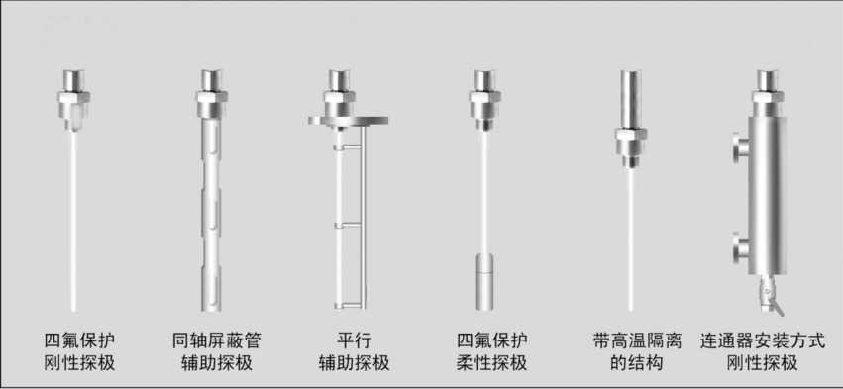
六、 Installation
Connection Methods:
- Threaded connection
- Flanged connection
- Sanitary quick-clamp connection
Installation Guidelines:
1. Secure flexible probes at the tank bottom with tensioning devices.
2. Use a wrench only on the hexagonal process connector; avoid applying force to other components.
3. Position probes away from top-fill inlets to prevent liquid splashing.
4. Ensure proper electrical contact between the gauge and metal tanks (auxiliary probes required for non-metal tanks).
5. Tighten the cable gland after wiring.
6. For media temperatures exceeding 70℃, a custom heat-dissipation structure is required.

七、 Wiring
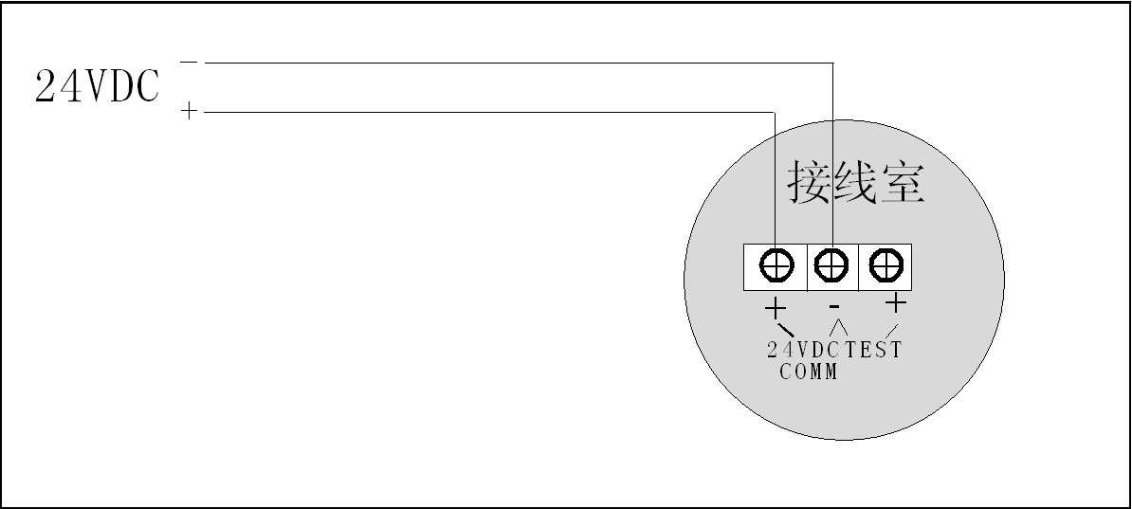
Terminals are located in the side terminal chamber. Refer to the wiring diagram provided.
八、Calibration
Prerequisites:
- Ensure the gauge is electrically connected to the metal tank (use auxiliary probes for non-metal tanks).
- Factory calibration is performed in water. Recalibrate on-site using the actual liquid medium.
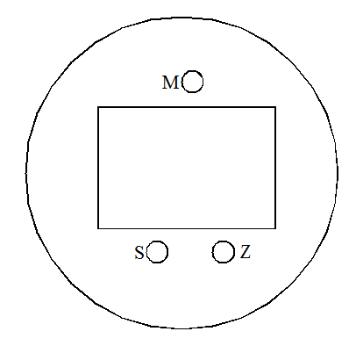
Control Panel:
Zero Key (Z)
-Span Key (S)
-Function Key (M)

Calibration Steps:
1. Unlock: Press and hold **<Z>** and **<S>** for **>5 seconds** (display shows **"OPEN"**).
2. Reset PV: After unlocking, press **<Z>** and **<S>** for **>2 seconds** to set PV to **0** (display shows **"PV=0"**).
3. Zero Calibration: Place the gauge at the **lowest measurement level**, press **<Z>** for **2 seconds** (output: **4.000mA**, display shows **"LSET"**).
4. Span Calibration: Place the gauge at the **highest measurement level**, press **<S>** for **2 seconds** (output: **20.000mA**, display shows **"HSET"**).
Factory Reset:
- Hold **<Z>** while powering on the device for **>5 seconds**.
- "OK" indicates successful restoration to factory settings.
- "FAIL" indicates no backup data exists.

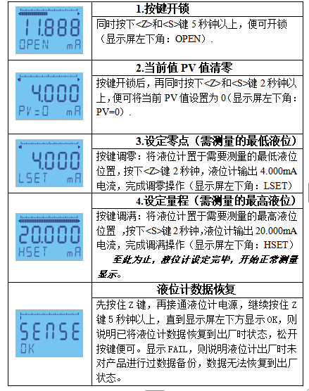

AM9080S Model Selection Guide
